Project Proposal

Academic Year 2021

Candidate Details

Index No: 1805274

Name of candidate:

Gamage Pavithra Sankalpa

Address:

58/E, Kesbewa Road, Kamburugoda, Bandaragama

Contact telephone numbers:

0757003662

Email:

gamage2pavithra@gmail.com

Supervisor/Advisor Details

|  |  |  |
| --- | --- | --- |
|  | Supervisor 1 (IT Related) | Supervisor 2 (Optional) |
| Name | Mr. M.P Sarath Wijeshinghe |  |
| Designation | Assistant Director - IT |  |
| Workplace address | Sri Lanka Export Development Board,  No 42, Nawam Mawatha, Colombo 02. |  |
| Academic/   * Degree in Statistics & Computer Sciences, University of Sabaragamuwa * Post Graduate Diploma in Information Technology University of Sabaragamuwa * Certificate in PHP and MySql, Sri Lanka Institute of Information Technology. (SLIIT) * Certificate in Web Development, Sri Lanka Institute of Information Technology. (SLIIT) * Certificate of Creating Quality E-commerce Content conduct by SME   Certificate Verification Link - <https://learning.intracen.org/verify/?q=s8YMTJ75uD>  professional/  qualifications  and  memberships |  |  |
| Work experience   * Assistant Director - Information Technology Export Development Board * 3 years’ experience in managing E-Commerce and Software Development * 04 years’ experience in supervising projects at tertiary * 7 years’ experience of Software Development * 12 years’ experience in implementing IT Projects | [mpsarathw@gmail.com](mailto:mpsarathw@gmail.com)  [sarathw@edb.gov.lk](mailto:sarathw@edb.gov.lk) |  |
| Email: |  |  |
| Phone number/s | 0112300705  0718080409 |  |

Note: Any deviation of the final project from the project described in this proposal should   
 be explained by the candidate in the dissertation.

Project Details

Title of Project:

Web based system for managing computer hardware and services for Encryption IT Solutions

If Repeat Student

Number of Attempt(s):

Previous Decision: 



Earlier Project Title:

Name and address of client:

Encryption IT Solutions

NO: 51/L, New Shopping Complex,

Kaluthara Road,

Bandaragama.

**Motivation for project: (Check)**

The computer sales and servicing sector sell and service many types of computers, including desktops, laptops, notebooks, palmtops, and software, as well as peripherals such as printers, scanners, and keyboards. These products are often purchased from domestic and foreign producers and distributors before being sold to end-users, such as households and enterprises. Once in a while, Encryption IT Solutions emerges that genuinely delivers on its promises, exceeding consumers' expectations and exceeding their imagination.

Encryption IT Solutions is a renowned information and communication technology (ICT) company that has been in existence since 2010. They provide an unrivaled program and experience in ICT equipment repair, servicing, maintenance, and cleaning. They are depending on its technically advanced next-generation infrastructure to deliver best in class customer-aware and lifestyle-enhancing products and services that anticipate customers' needs.

Customers are on the go, busy, and mobile, and they want frictionless and seamless services. By gaining a solid understanding of the needs of customers We provide a convenient product browsing experience, a simple payment system, and a delivery tracking system that allows customers to track their order as it arrives at their home. In addition, we spoke with shop technicians and discovered that the average person has just around 25% of the average understanding of how to purchase items to build a computer. Others require technical support to purchasing products. We decide to use a virtual assistant to aid the rest of the team who are unfamiliar with computer hardware. Also, the consumer has less time to troubleshoot computer hardware. We decided to create an efficient repair management module with an appointment booking module as a computer hardware service provider to prevent consumers from wasting time at their repair location. It is more important to deal with the items’ warranties. We decide to add a warranty checking feature that allows consumers to check the warranty status of individual parts purchased from the shop.

We can find an outstanding solution for Encryption IT Solutions to continue their greatness in the computer sales and maintenance sector in this digital age. Furthermore, while pursuing a Bachelor's degree in Information Technology, this effort would substantially assist me in improving my project management, system analysis, design, and development abilities.

**Objectives and scope of proposed project: (Check)**

**Objectives**: **(Check)**

The study's overall goal is to build and develop an online system for managing computer hardware and services that will assist the company and its employees in becoming more popular with their consumers and marketing their business through the internet.

The study's particular objectives are as follows:

* Include a virtual computer hardware assistant to let customers design a custom computer even if they don't know anything about computer hardware.
* Using an automated question-based module to implement Online Troubleshooting and suggest appropriate items that are currently in stock.
* Including an appointment management module for taking care of appointments from clients who are having issues with their current stuff.
* Providing a feature-rich product browsing method, as well as a simple payment and shipping mechanism, to fulfill the customer's order.
* Implementing a warranty checker to whether the items bought by the customer are still covered under warranty.
* Inventory management, which makes it easy to create items for the store and receive automated alerts when stock levels are low.
* Generate a variety of reports and graphics, including sales and stock data, to assist management in making decisions.

**Scope**: **(Check)**

* User Management Module
  + This module helps to manage all of the system's users. It aids in the selection of the right individual for the right position.
* Report Management Module
  + This module will make it possible to generate, preview, and print a variety of reports in order to continue with the business's success.
* Backup and System Log Module
  + This Module enables the backup of system data and extracts the system log such that the system may be audited for any additional issues.
* Inventory Management Module
  + Has the ability to handle the complete inventory. Individual items and corresponding categories, brands, and models can be added, deleted, and updated.
* Shopping Cart Module
  + This module allows users to find the entire store for items and create customer orders using a shopping cart.
* Payment Module
  + This module provides up-to-date information on all payments made by customers, as well as advanced payment filtering options and having bank transfers, and cash on delivery options.
* Delivery Management Module
  + This module contains all of the customer-created delivery records in the system. It displays the order tracking number as well as information about the courier company.
* Computer Hardware Assistant Module
  + This module assists customers who are unfamiliar with computer hardware. It takes all of the individual item's details and matches them with the next most appropriate piece, completing the assembly of an entire computer. After completing customers have an option to check out the selected parts and make a payment to complete the assistant process.
* Invoice Genarationg Module
  + In the system, this module generates a variety of invoices. It's compatible with the payment, computer hardware assistant, and troubleshooting modules.
* Appointment Booking Module
  + This module aids in the scheduling of appointments for clients who wish to troubleshoot with in-house computer hardware professionals.
* Troubleshooting Assistant Module
  + With the help of this virtual assistant, consumers may troubleshoot their hardware failures without having to visit a computer repair shop, and they can order the right parts that the fault has accurately recognized. Customers can schedule an appointment with one of the computer hardware technicians if the problem is not resolved.
* Warranty Management Module
  + This module aids in the generation of warranty alerts. It shows the status of the goods' warranties and how much time is left on each item's warranty.

**Critical functionalities for project: (Check)**

* Computer Hardware assistant with appropriate item specifications to match with other hardware items.
* The questions in the Troubleshooting Assistant Module differ depending on the type of failure.
* The invoice-generating module calculates the total value of the items without any mathematical errors.
* Create reorder amounts in the inventory management module using the first in first out procedure and send alerts to the necessary corporate personnel.
* Appointment booking time does not overlap with earlier dates or the duration of the booking time.
* Authentication and authorization of users, as well as safe access.

**Itemized list of deliverables of the system:**

Note: Deliverables are items that you would deliver to the client at the end of the project.

* Project Proposal
* Website
* A fully functional finalized content management system.
* Test plan and Test results
* User manual
* User training
* Source code

A project plan using Gantt chart (include the work involved in system development as well as writing the dissertation):

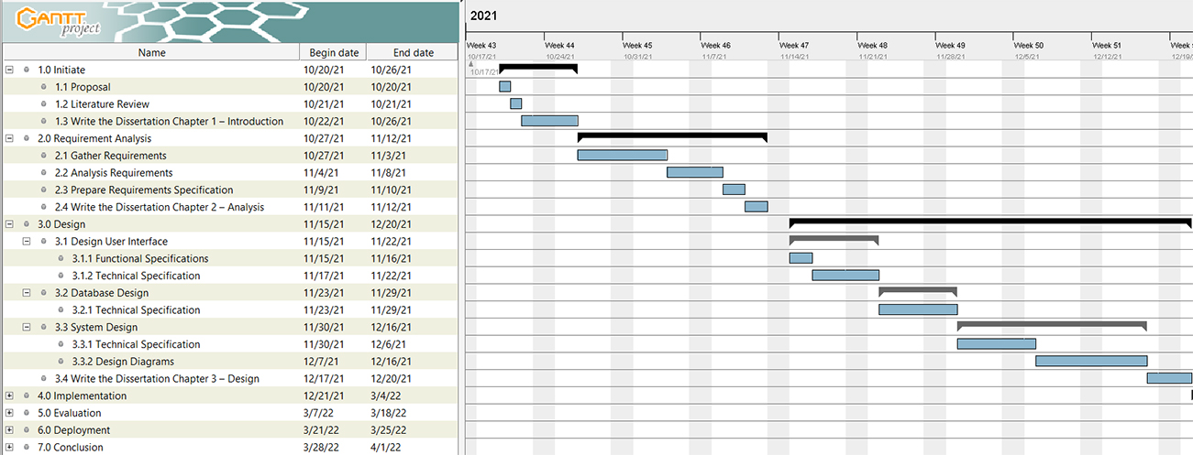

**Resource requirements for project (e.g., hardware, software,...):**

Hardware requirements as a sever

* Processor – Intel Core i7 fourth-generation or upper.
* Ram – 8GB
* Storage – 20GB HDD Drive
* 1Mbps network connection

Hardware requirements as an end-user

* Processor - Intel Core i3 first-generation or upper
* Ram – 4GB
* 1Mbps network connection

Software requirements as a sever

* Windows 8 or higher OS
* Apache server,
* PHP 7.4 higher
* MySql
* Chromium-based v76 or Firefox v73 or higher web browser.

Software requirements as an end-user

* Windows 8 or higher OS
* Chromium-based v76 or Firefox v73 or higher web browser.

**Proposed way of self-evaluating the success of your system:**

* Ensure that all customer needs are documented in accordance with the scope.
* Unit testing of each level of the source code and ensuring that there are no syntax issues.
* Use test data to evaluate the software and operational behavior.
* Test a final functional system in client environments to ensure that it meets all of the customer's needs.
* With the customer, perform user acceptance testing.